# Tooth Measurement Dataset

## Model Evaluation:

|  |  |  |  |  |
| --- | --- | --- | --- | --- |
| **Model** | **Features** | **Logistic Accuracy** | **KNN Accuracy** | **SGD Accuracy** |
| 1 | * Inter canine distance intraoral * left canine width casts | 79% | 83% | 77% |
| 2 | * inter canine distance intraoral * left canine width casts * left canine index casts | 79% | 83% | 77% |
| 3 | * inter canine distance intraoral * left canine width casts, * left canine index intraoral | 79% | 83% | 77% |
| 4 | * inter canine distance intraoral * left canine width intraoral | 78% | 83% | 77% |
| 5 | * left canine width casts, * right canine width casts * left canine index casts | 80% | 88% | 78% |
| 6 | * left canine width intraoral * right canine width intraoral * left canine index intraoral | 78% | 87 | 77% |

## Logistic Regression Model:

|  |  |
| --- | --- |
| **Model 1** |   **Model 2** |
|  |  |
|   **Model 3** |   **Model 4** |
|  |  |
|   **Model 5** |   **Model 6** |

### Model 6:

|  |  |
| --- | --- |
| Log Loss | 7.11 |
| Confusion Matrix | [[139 26]  [ 42 123]] |
| Sensitivity score | 0.83 |
| Specificity score | 0.77 |
| Precision | 0.75 |
| F1 score | 0.78 |
| Average Accuracy | 0.79 |
| ROC_AUC score | 0.79 |

## KNN Model:

Visualizing KNN accuracies of all the above models

### Model 6:

|  |  |
| --- | --- |
| Confusion Matrix | [[127 11]  [ 27 110]] |
| Sensitivity score | 0.91 |
| Specificity score | 0.82 |
| Precision | 0.8 |
| F1 score | 0.85 |
| Accuracies (n -neighbours(1-4): | [0.87, 0.87, 0.89, 0.86] |
| ROC_AUC score | 0.86 |

## SGD Model:

### Model 6:

|  |  |
| --- | --- |
| Confusion Matrix | [[125 13]  [ 38 99]] |
| Sensitivity score | 0.88 |
| Specificity score | 0.77 |
| Precision | 0.72 |
| F1 score | 0.8 |
| Average Accuracy | 0.81 |
| ROC_AUC score | 0.78 |

## P-Values for above models with selected features:

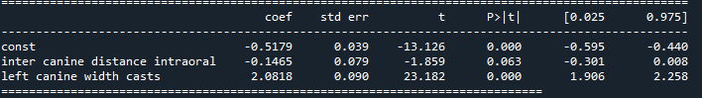

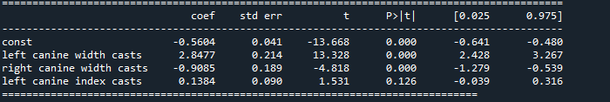

The *p* values for all independent variables are significant (*p* < 0.05) for model 6 and model 4 and suggests that these variables are highly associated with the outcome.

**Model 6 with features “left canine width intraoral”, “right canine width intraoral”, “left canine index intraoral” seem to be the fittest model with P-value <0.05 and gives better accuracy compared to other models. KNN algorithm gives the good results.**